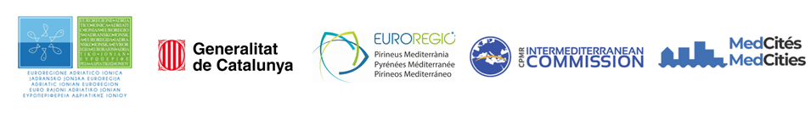
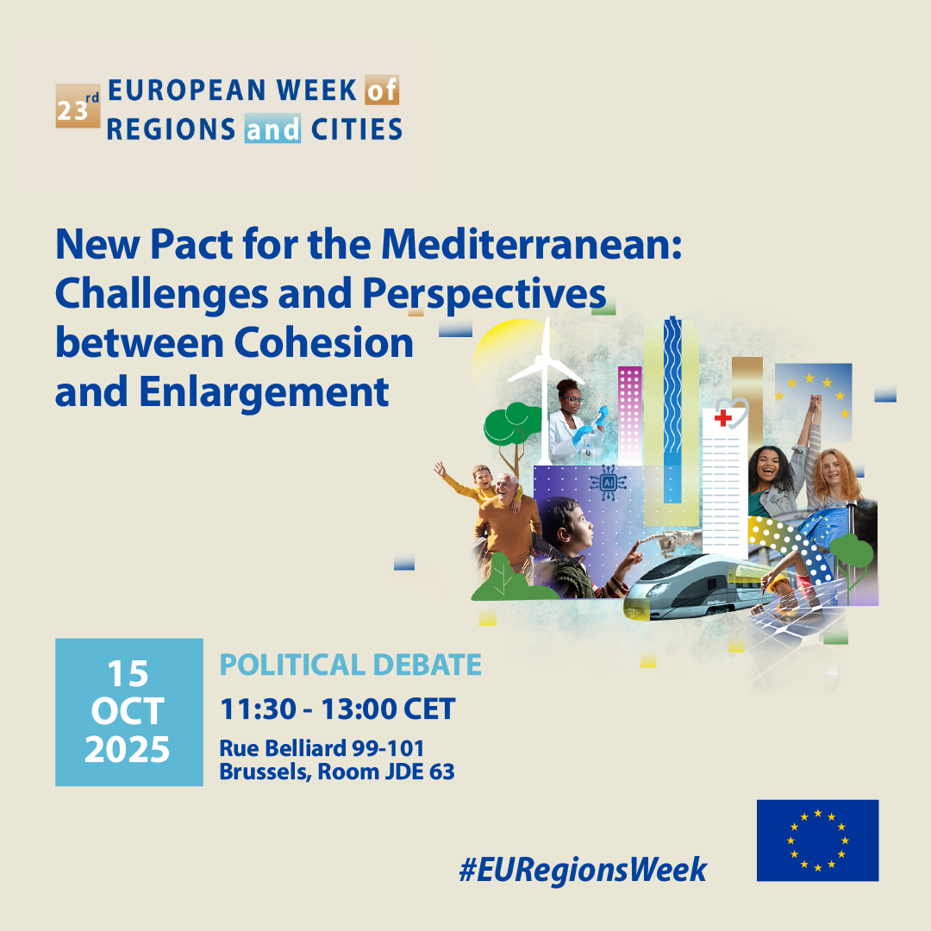

Organized by the Adriatic Ionian Euroregion in partnership with the Med Cooperation Alliance (Generalitat de Catalunya, Conference of Peripheral Maritime Regions, Euroregion Pyrenees Mediterranean and MedCities)

New Pact for the Mediterranean: Challenges and Perspectives between Cohesion and Enlargement

Organized in the framework of European Week of Regions and Cities 2025

#EURegionsWeek

Wednesday, 15 October 2025
Brussels

Time: 11:30 – 13:00 CET

Format: Policy Debate
Committee of the Regions – Rue Belliard 99-101, Brussels
Room: JDE 63
Room Capacity: 72 + Speakers and Moderators
Interpretation: English, Croatian, Spanish

Description of the Event
The Mediterranean region has once again become a strategic crossroads at the heart of global dynamics, marked by complex challenges but also extraordinary opportunities for cooperation. Within this framework, the debate on the New Pact for the Mediterranean aims to shape a political, social and economic agreement that strengthens regional integration, promotes cohesion between the northern and southern shores, and addresses the tensions linked to enlargement and differentiation processes. The event aims to foster a shared reflection on the future of Mediterranean cooperation, to reflect on the role of local and regional authorities in support of greater fairness and sustainability.
The debate aims to promote a common political vision for a New Pact for the Mediterranean, fostering dialogue and cooperation between both shores of the region. It will address pressing issues such as regional integration, the impact of enlargement, and the role of local and regional authorities in ensuring sustainable and cohesive development across the Mediterranean basin.

AGENDA
Moderator: Elodie NUNES, Executive Secretary of the Intermediterranean Commission at Conference of Peripheral Maritime Regions (CPMR)

Introduction
11:30 - 11:35 - Welcome of participants and introduction to the session
Elodie Nunes, Executive Secretary of the CPMR Intermediterranean Commission
11:35 - 11:40 - Welcome address
Nikola Dobroslavić, President of the Adriatic Ionian Euroregion
11:40 - 11:55 - Keynote speech
Dubravka Šuica, EU Commissioner for the Mediterranean

Panel Interventions
11:55 - 12:05 - Nikola Dobroslavić, President of the Adriatic Ionian Euroregion
12:05 - 12:15 - Margalida Prohens, President of the Euroregion Pyrenean Mediterranean, President of Balearic Islands
12:15 - 12:25 - Jaume Duch - Regional Minister, Government of Catalonia
12:25 - 12:30 - Comprehensive answer by Dubravka Šuica
12:30 - 12:50 - Interactive discussions with audience
12:50 - 13:00 - Wrap-up and conclusions
Elodie Nunes, Executive Secretary of the CPMR Intermediterranean Commission
*

